Date: 13 / 08 /25

Lab Practical #05:
Study the concept of VLAN using packet tracer. Practical Assignment #05:
- Implement the different network structures in VLAN and VLAN trunking. Also check connectivity between them using ping command or PDU utility.
Instructions:
  - Different VLANs configuration setup screenshot. (VLAN example given by lab faculty)

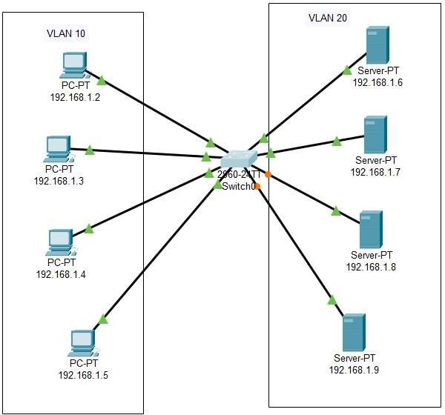







1
Enrollment No: - 23010101048
| B.Tech. CSE

Date: 13 / 08 /25

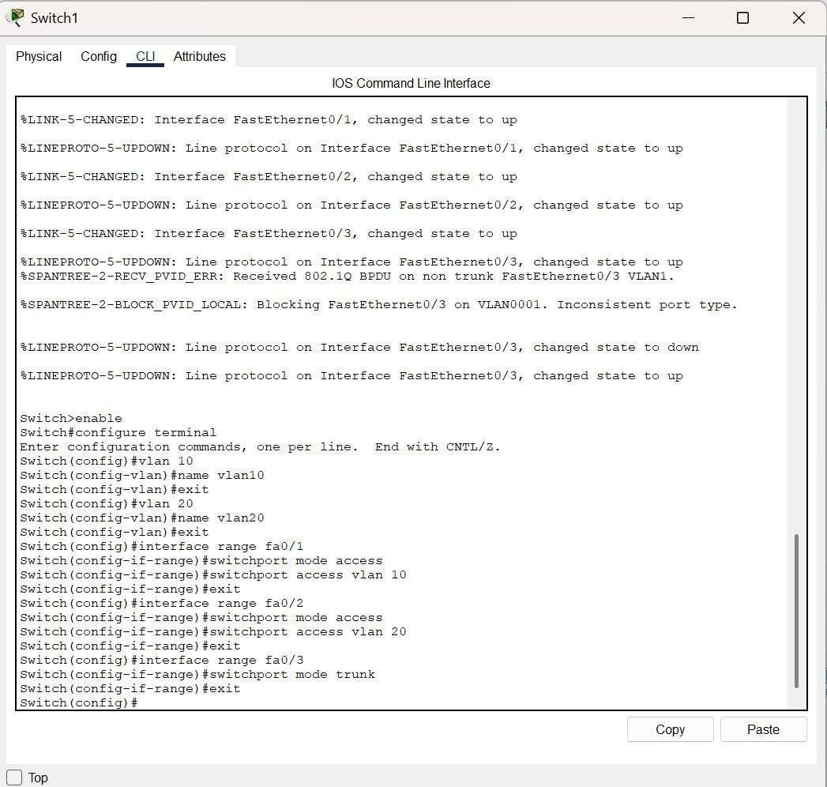
  - Write steps to create VLANs in packet tracer.

Date: 13 / 08 /25

  - Mention IP address of each pc as label.
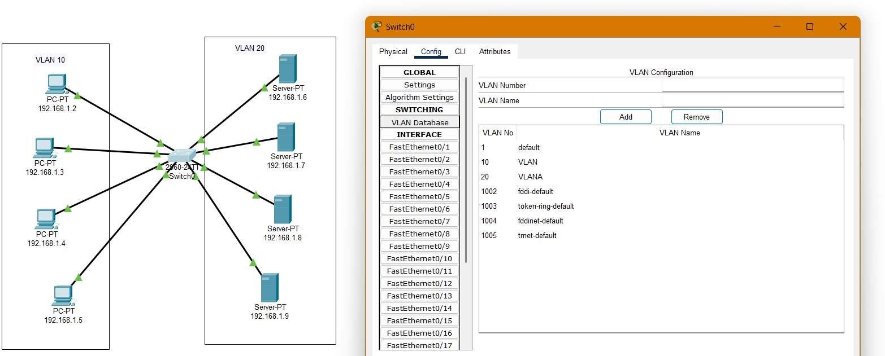
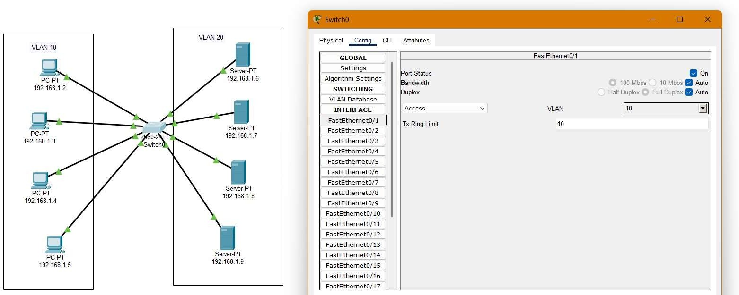

  - Ping command or PDU screenshot between two VLANs.

Date: 13 / 08 /25

